EXPT NO: 5 | IMPLEMENTATION OF A RECURRENT NEURAL NETWORK (RNN) FOR TEXT GENERATION
DATE: 24.08.26

PRE-LAB QUESTIONS

1. Explain the purpose of a Recurrent Neural Network (RNN) in processing sequential data.
Answer: An RNN is designed to process sequential data by considering the current input along with information from previous inputs.
It maintains information from earlier time steps using its hidden state.
This helps the network identify patterns and dependencies in the sequence.
Therefore, RNNs are useful for tasks involving text, speech, and time-series data.

2. Why is an RNN considered an appropriate model for text generation tasks?
Answer: Text is sequential because the meaning of a word often depends on the words that come before it.
An RNN can remember information from previous words while processing the current word.
It uses this learned context to predict the next word in a sequence.
Therefore, RNNs are suitable for generating meaningful text.

3. Describe the concept of sequence modeling in Natural Language Processing.
Answer: Sequence modeling is the process of learning patterns and relationships between elements in a sequence.
In NLP, the elements are usually words or tokens in a sentence.
The model learns how previous words are related to the next words.
This helps in tasks such as text generation, prediction, and language understanding.

4. Explain the importance of tokenization during text preprocessing for RNN-based text generation.
Answer: Tokenization is the process of dividing text into individual words or tokens.
It converts unstructured text into smaller units that can be processed by the model.
Each token can then be assigned a unique numerical index.
Therefore, tokenization is an important step before training an RNN.

5. Explain the significance of converting text into numerical representations before training an RNN.
Answer: Neural networks cannot directly process normal words or textual characters as input.
Therefore, words must be converted into numerical representations such as integer indices.
These numerical values can be provided as input to the RNN model.
This allows the network to learn patterns and relationships from the text data.

AIM
To implement a Recurrent Neural Network (RNN) for text generation and evaluate its ability to generate meaningful text by predicting the next word in a sequence.

SOFTWARE REQUIREMENTS
- Python
- TensorFlow or keras or PyTorch
- Google Colab
- GitHub
- Numpy
- Matplotlib

OBJECTIVES
Students will be able to:
- Understand the architecture and working of Recurrent Neural Networks (RNNs).
- Perform text preprocessing techniques for sequence modeling.
- Generate input sequences suitable for training an RNN model.
- Build and train an RNN model for text generation.
- Generate text by predicting the next word in a sequence.
- Evaluate the performance of the trained RNN using generated text.
- Analyze the effectiveness of RNNs in learning sequential patterns from textual data.

PROCEDURE
PART A: DATASET PREPARATION
Perform the following tasks:
- Load the Tiny Shakespeare dataset from Hugging Face.
- Explore the dataset and examine the text samples.
- Convert the text into lowercase (if required).
- Tokenize the text into individual words.
- Build a vocabulary and assign a unique integer index to each word.
- Generate input sequences for next-word prediction.
- Apply sequence padding to obtain inputs of equal length.
- Split the prepared sequences into training and validation datasets.

(CODE: CONATAINS STUDENT ROLL NOS
SCREENSHOT OF CODE
SCREENSHOT OF OUTPUT)

PART B: IMPLEMENTING THE RNN MODEL
Perform the following tasks:
- Create an Embedding layer to convert words into dense vector representations.
- Add a Simple RNN layer to learn sequential dependencies in the text.
- Add a Dense output layer with Softmax activation for next-word prediction.
- Compile the model using an appropriate optimizer and loss function.
- Display the model architecture and summary.

(CODE: CONATAINS STUDENT ROLL NOS
SCREENSHOT OF CODE
SCREENSHOT OF OUTPUT)

PART C: COMPARISON OF OPTIMIZATION ALGORITHMS
Perform the following tasks:
- Train the RNN model using the prepared training dataset.
- Validate the model using the validation dataset.
- Record:
  - Training accuracy
  - Validation accuracy
  - Training loss
  - Validation loss
- Visualize:
  - Accuracy vs. Epoch
  - Loss vs. Epoch

(CODE: CONATAINS STUDENT ROLL NOS
SCREENSHOT OF CODE
SCREENSHOT OF OUTPUT)

PART D: DEEP LEARNING EXPERIMENT MANAGEMENT
Perform the following tasks:
- Provide a seed word or sentence as input to the trained model.
- Generate text by repeatedly predicting the next word in the sequence.
- Produce multiple text samples using different seed inputs.
- Compare the generated text for coherence and contextual relevance.
- Document the observations and upload the notebook to GitHub.

CODE:
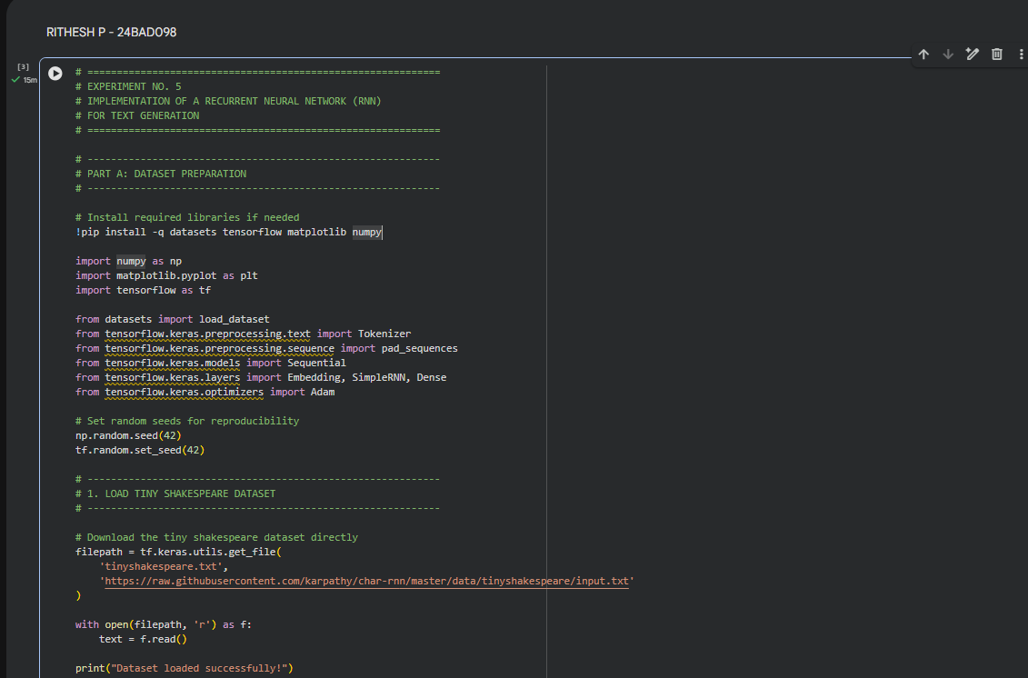
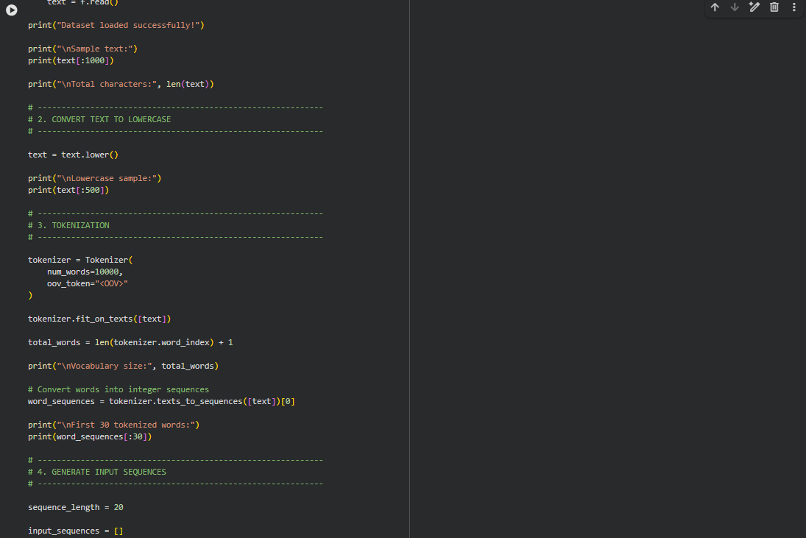
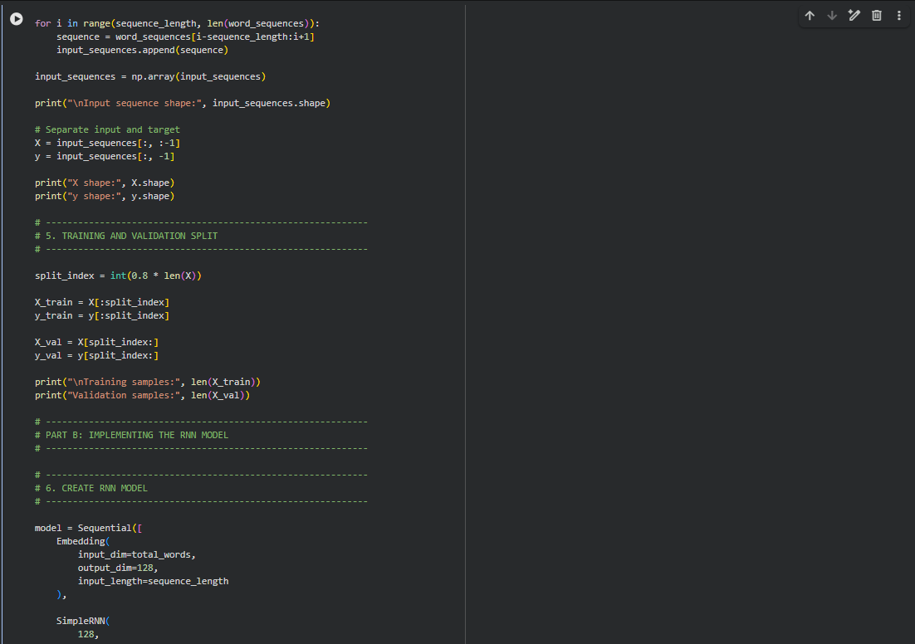
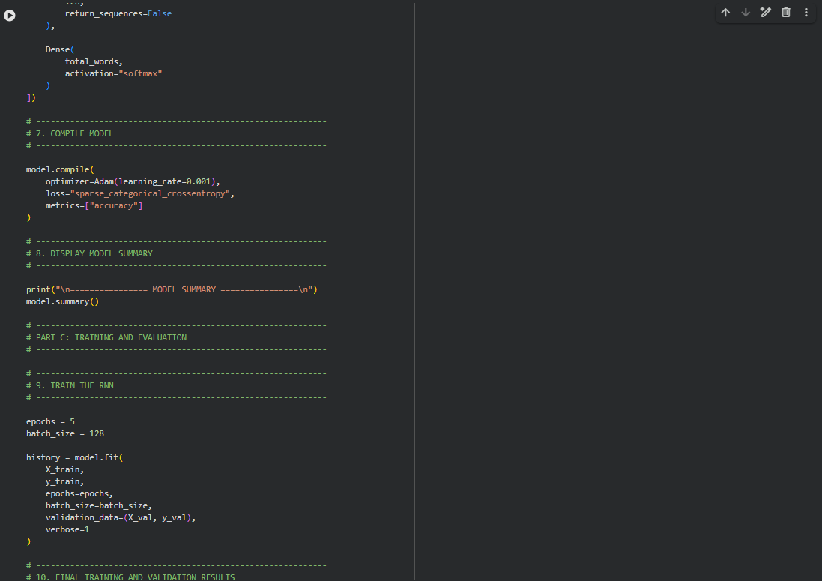
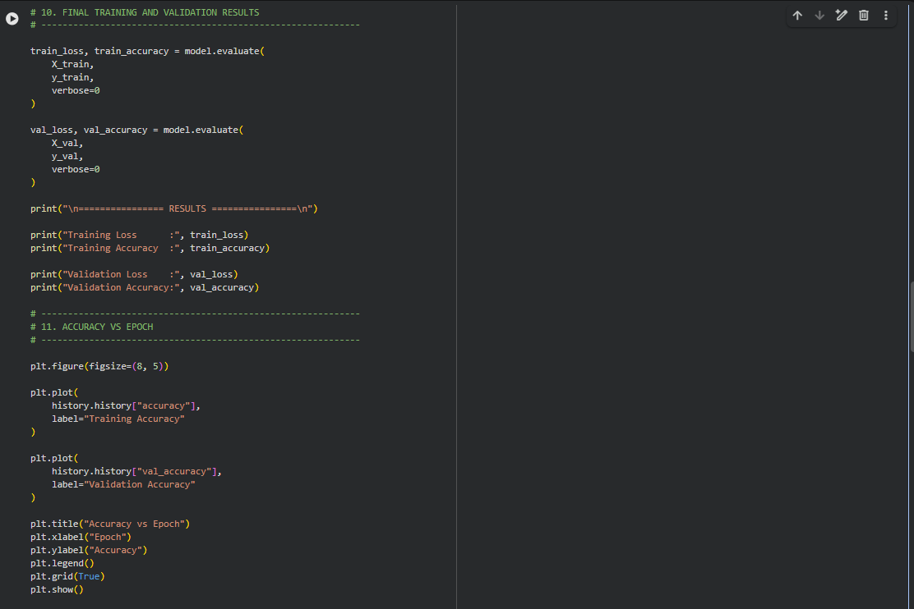
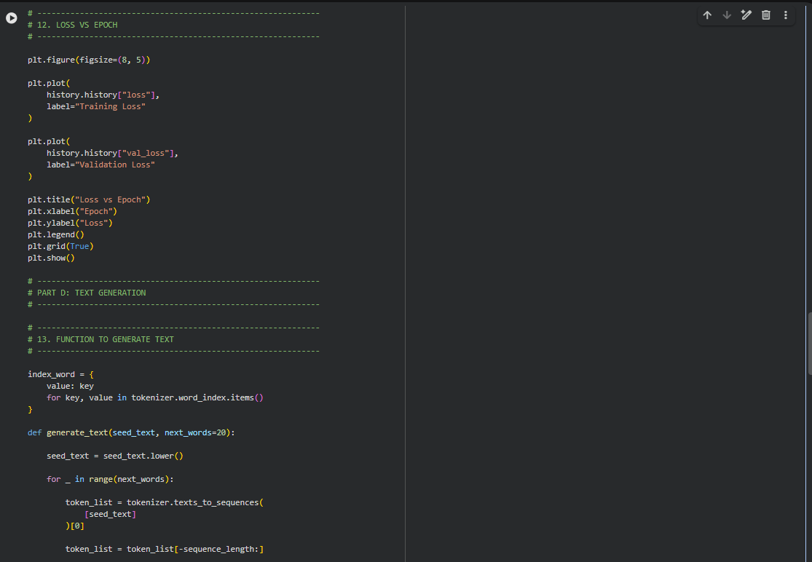
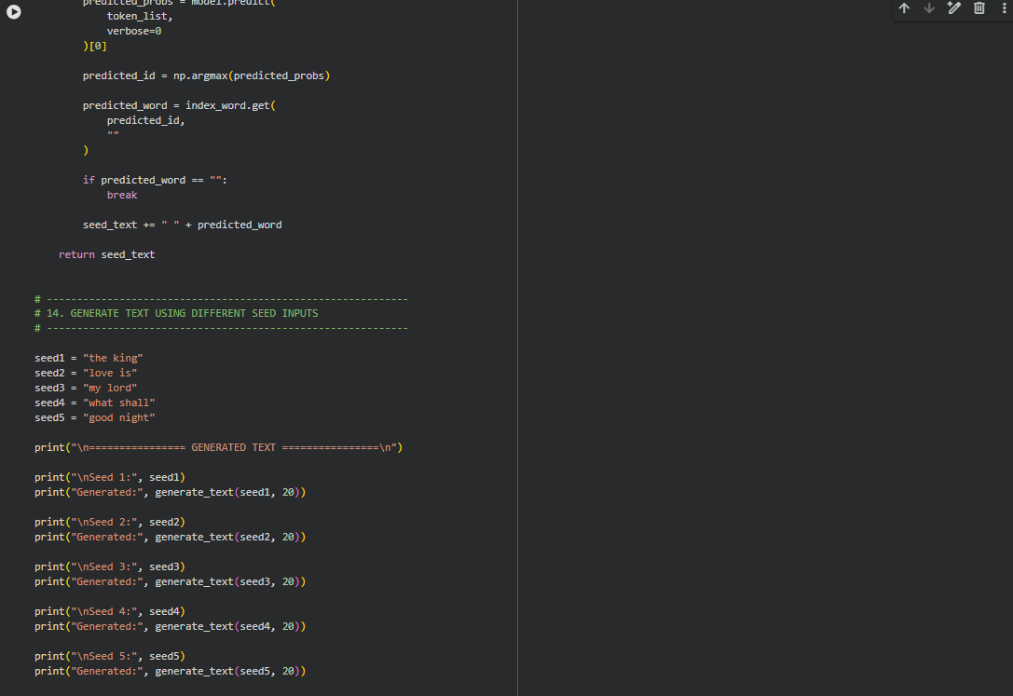
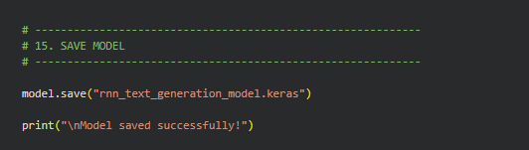

OUTPUT:
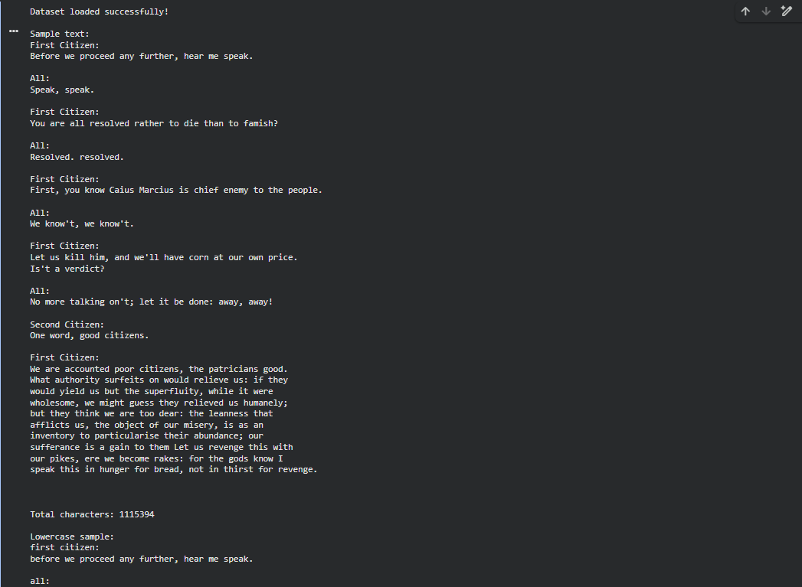
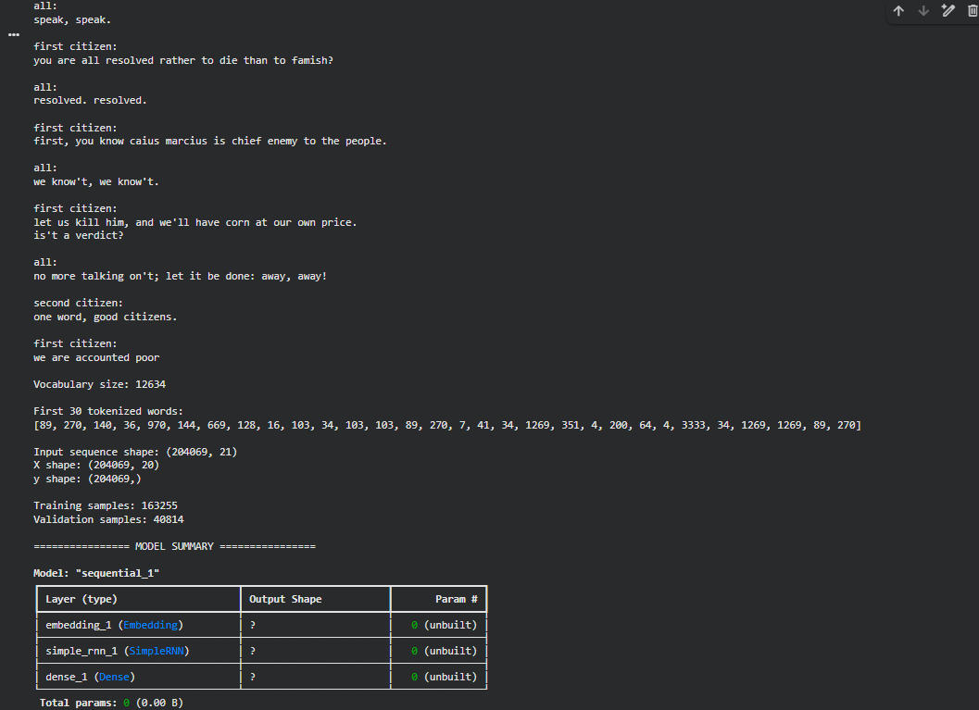
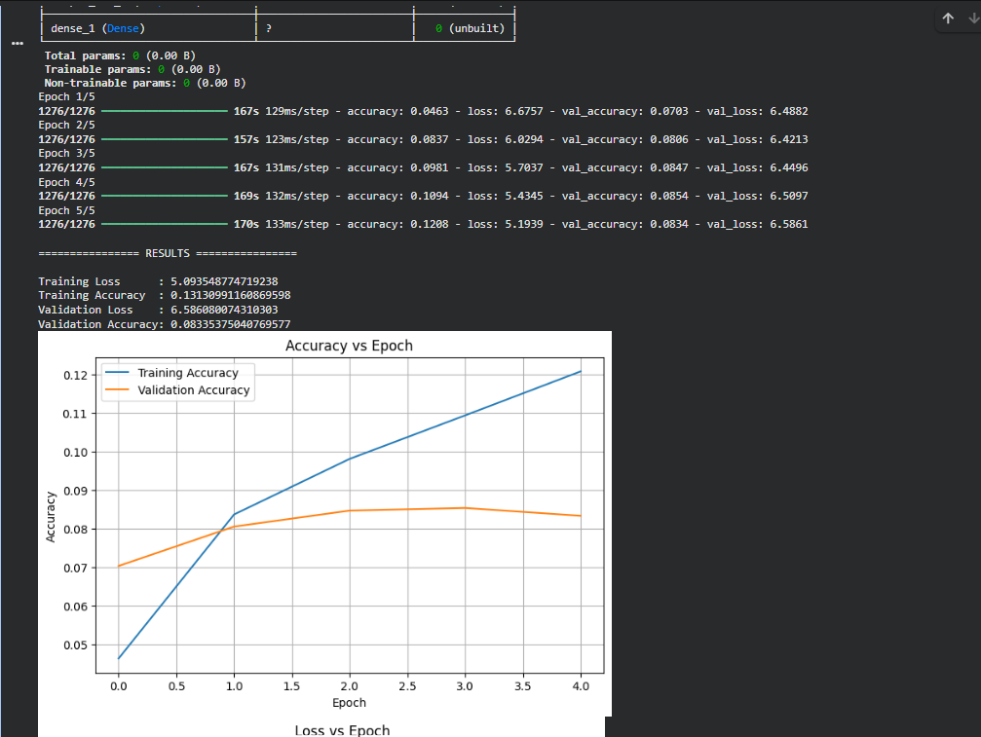
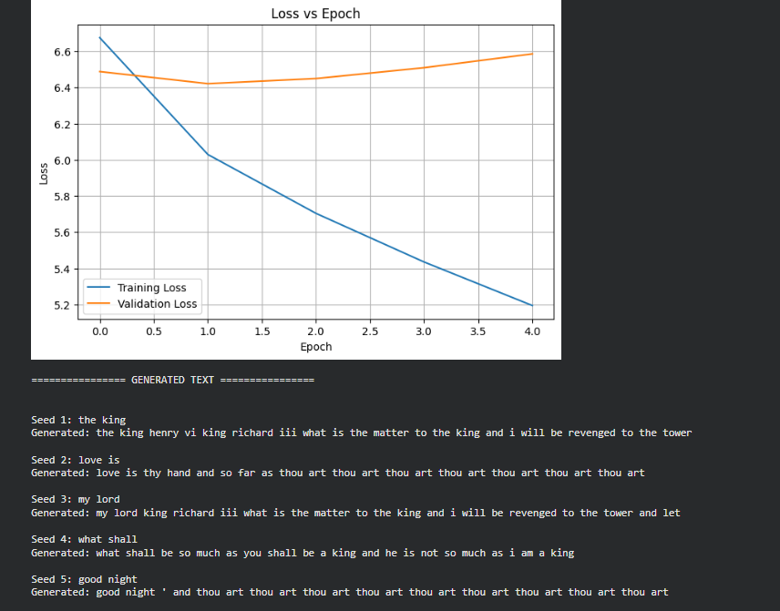

EXPECTED OUTCOME
Students will understand how an RNN learns sequential information and generates meaningful text based on previously learned patterns. Students will learn to preprocess textual data and train a Recurrent Neural Network (RNN) for text generation. They will evaluate the model's performance using training metrics and generate text through next-word prediction.

POST-LAB QUESTIONS

1. Describe the role of the hidden state in an RNN during sequence processing.
Answer: The hidden state stores information learned from previous elements of the sequence.
It is updated whenever the RNN processes a new input.
The information from the previous time step is combined with the current input.
Thus, the hidden state helps the RNN remember contextual information.

2. Discuss the effect of training an RNN model for an insufficient number of epochs.
Answer: Training an RNN for too few epochs may prevent it from learning the required patterns.
The model may not adequately learn the relationships between words in the text.
This can result in lower training and validation performance.
Consequently, the generated text may be less meaningful or coherent.

3. Explain the purpose of padding when preparing text sequences for RNN training.
Answer: Padding is used to make input sequences have the same length.
Sequences containing fewer elements are filled with padding values.
This allows multiple sequences to be processed together efficiently by the RNN.
Therefore, padding is important when preparing sequences for model training.

4. Discuss one limitation of a Simple RNN when processing long text sequences.
Answer: A Simple RNN has difficulty learning dependencies that occur over very long sequences.
During training, it can suffer from the vanishing-gradient problem.
As a result, information from earlier parts of a long sequence may be lost.
Therefore, Simple RNNs are less effective for learning long-term dependencies.

5. Discuss the effect of sequence length on the performance of the text generation model.
Answer: Sequence length determines how much previous text the model can use for prediction.
A longer sequence can provide more contextual information to the RNN.
However, longer sequences require more computation and can make training difficult.
Therefore, an appropriate sequence length should be selected for good performance.

ASSESSMENT
Description | Max Marks | Marks Awarded
Pre Lab Exercise | 5
In Lab Exercise | 10
Post Lab Exercise | 5
Viva | 10
Total | 30
Faculty Signature

